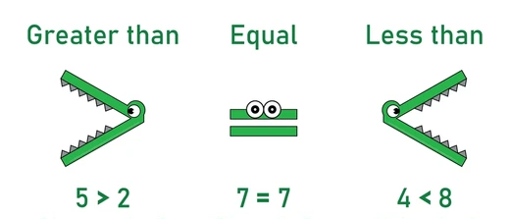
Can you write two sentences about a book you love reading?

1.___________________________________________________________________________________________________________________________________________________________________________
2.__________________________________________________________________________________________________________________________________________________________________________
7 1

6 8

5 4

2 3

Can you fill in the gaps using a less than, equal to or greater than symbol?

4 6

3 3

2 8

9 5

