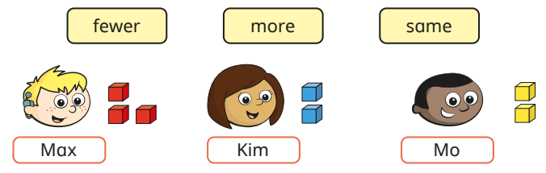
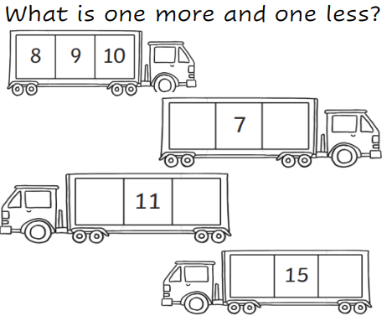
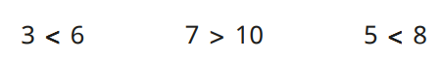
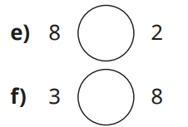
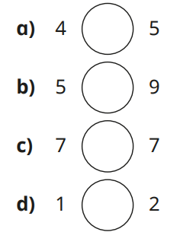
Use the words below to complete the sentences.
- Kim and Mo have the ___________ number of cubes.

- Kim has ___________ cubes than Max.

What is one more and one less?
Circle the statement that is false.
Fill in the gaps using <, > or = to compare the numbers.

