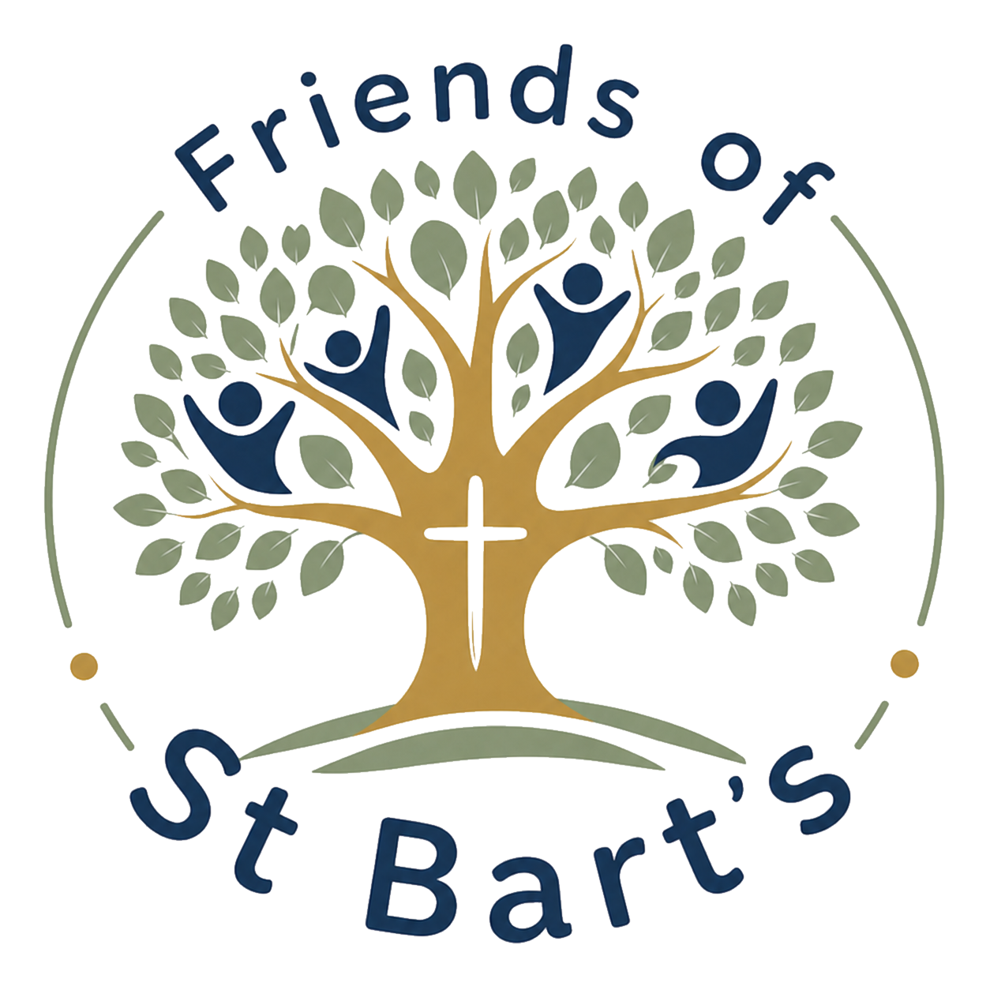
FOBS COMMUNITY MEMBER APPLICATION
Friends of St Bartholomew’s School

FOBS exists to strengthen the life of St Bart’s by bringing together parents, carers, staff and friends of the school to support our children, families and wider school community.
We know that some people who are no longer current parents or carers may still have a strong connection to St Bart’s and would like to remain involved. We therefore welcome applications from members of the wider school community who would like to join FOBS as a Community Member.
1. About You
Full name

Address

Email address | Telephone number

2. Your Connection to St Bart’s
Please tell us about your connection to the school.
For example, you may be a former parent or carer, former pupil, grandparent, former member of staff, church member, governor, local resident or friend of the school.
My connection to St Bart’s is

3. Why would you like to join or remain connected to FOBS?
Please tell us a little about why you would like to be involved with the school community.
Your response

4. What Could You Offer?
FOBS benefits from people with all sorts of interests, skills and experience. You do not need to be able to commit large amounts of time.
Please tell us about anything you might be happy to contribute. This could include:
• helping at events | • administration
• organising activities | • photography or design
• fundraising | • helping with refreshments
• practical or DIY skills | • supporting school or community events
• creative skills | • professional experience or advice
• publicity or social media | • simply being willing to lend a hand when needed
• links with local businesses or organisations
I could offer

5. How Would You Like to Be Involved?
Please tick any that apply:
☐ Attend FOBS meetings
☐ Help at occasional events
☐ Help organise events or activities
☐ Support fundraising
☐ Offer particular skills or expertise
☐ Help behind the scenes
☐ Support communication or publicity
☐ Help strengthen links with the wider community
☐ Other: __________________________________________

6. Our Shared Values
FOBS works alongside St Bart’s and seeks to reflect the values of our school community, including Service, Community and Compassion.
Community Members are expected to support the positive work of the school, treat children, families and staff with respect, and help FOBS remain welcoming and inclusive.
☐ Yes, I am happy to support these values and expectations.

7. Safeguarding
Being a member of FOBS does not automatically give access to pupils or school premises outside normal arrangements. Some volunteering activities may require additional safeguarding checks or supervision depending on the nature of the activity.
☐ I understand that appropriate safeguarding arrangements will apply to any activities involving children.

8. Community Membership and Conduct
FOBS is committed to being a welcoming, respectful and inclusive community. Community Members are expected to behave in a way that reflects the values of FOBS and supports positive relationships between families, staff, volunteers and the wider school community.
Where a member’s behaviour is considered inappropriate, disrespectful, disruptive or otherwise inconsistent with these expectations, FOBS may speak with the member and, where necessary, ask them to step down from their Community Membership. In serious circumstances, membership may be ended without further involvement.
☐ I understand and agree to uphold these expectations as a Community Member of FOBS.

9. Declaration
I would like to be considered for membership of FOBS as a Community Member.
I understand that membership is intended to support the work, ethos and community of St Bartholomew’s C of E Primary School and that applications will be considered by the FOBS committee in consultation with the Headteacher.
Signed | Date

